**Output:**

**i. User search page:**

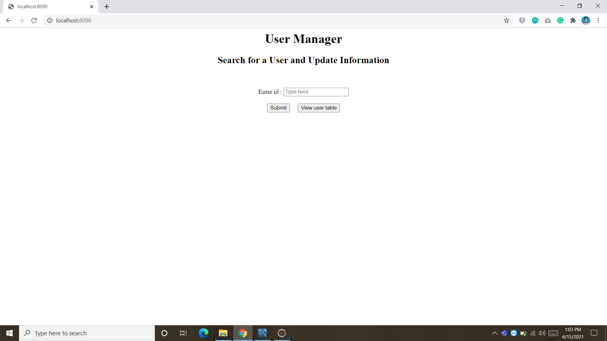

**ii. List of available users in the system:**

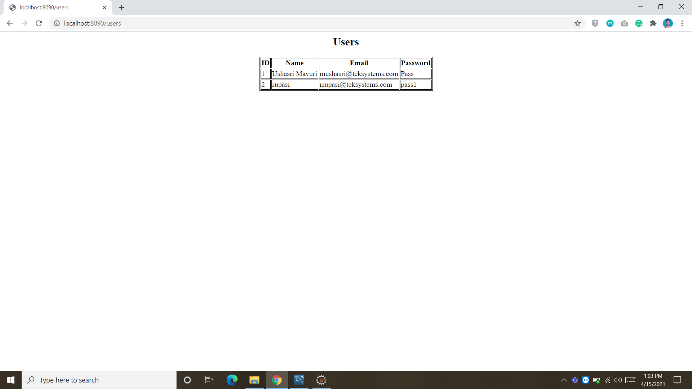

**iii. The system is asking for the ID number whose information is needed to be updated:**

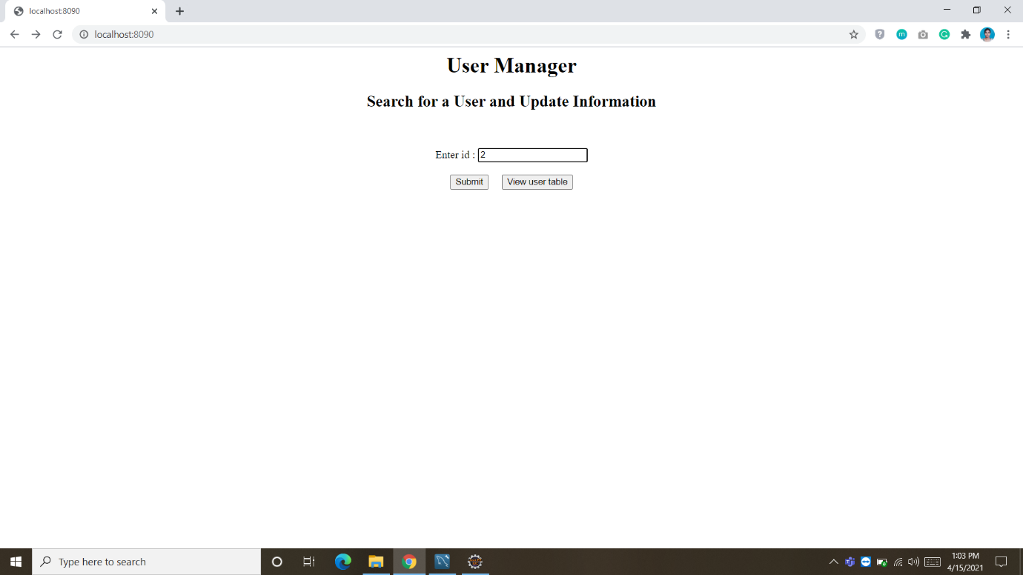

**iv. The current information of the selected ID number is displayed:**

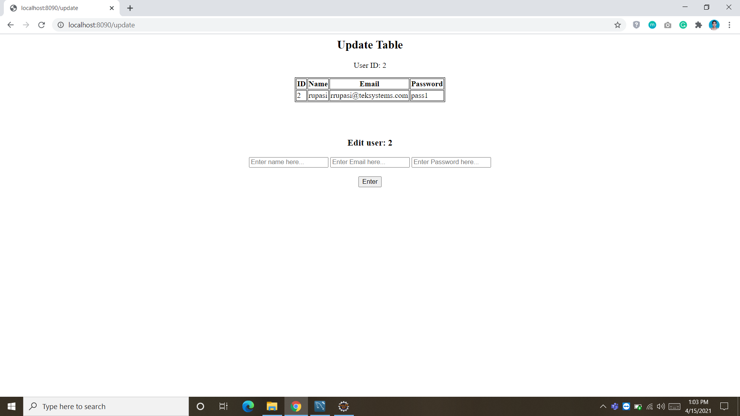

**v. The new information is provided:**

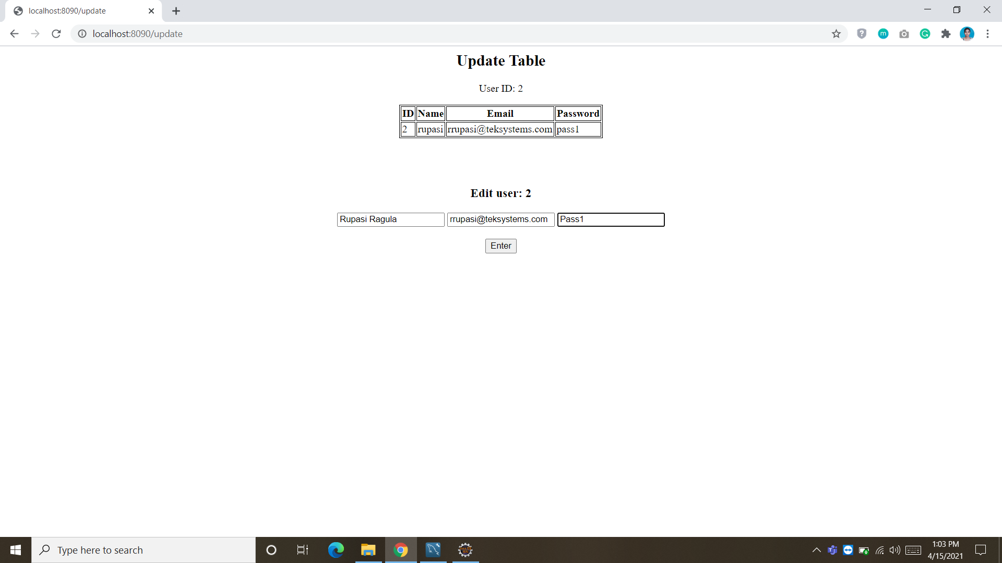

**vi. The name in the list has been updated successfully:**

